F:\F Drive-14 April 2019\HEALTH MED SCIENCE RES LTD\HMS RESEARCH NETWORK\logo.png

**Healthmed Journal of Pharmaceutical Sciences**

Journal Homepage: http://ps.healthmedsci.org/

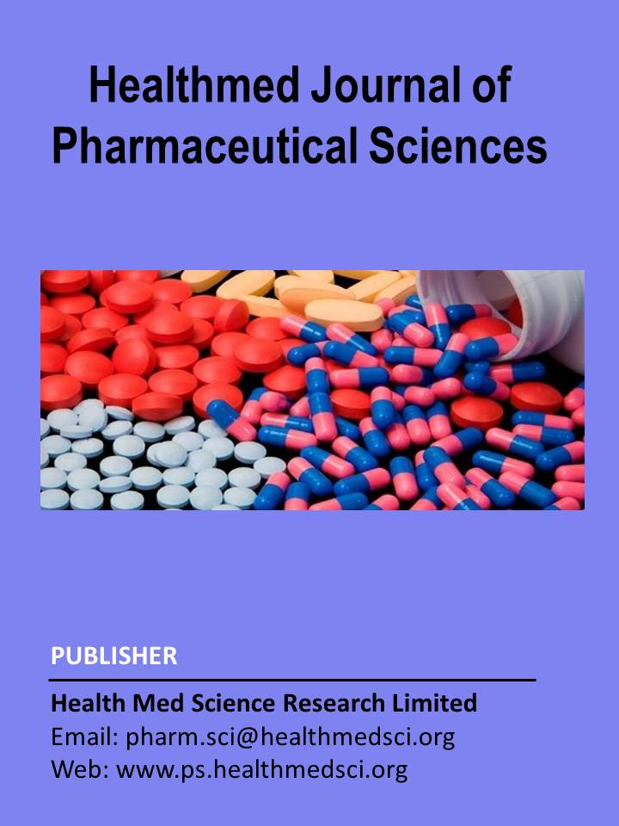

**Research Article (Mention Review or Research Article)**

**Comparative Clinical management, treatment pattern and medications of COVID-19 practiced at Dhaka city in Bangladesh: a randomized cross-sectional study**

(Over write your manuscript title on the above texts)

Tabassum Jannat1,2, Md. Moklesur Rahman Sarker3,4*, Safaet Alam5, Mst. Luthfun Nesa6, Selina Akhter7

(Write full authors name above and affiliations below as provided sample)

1Department of Pharmacy, University of Asia Pacific, 74/A Green Road, Dhaka, Bangladesh;

2Griffith Institute for Drug Discovery, Griffith University, Queensland, Brisbane, Australia;

3 Department of Pharmacy, Gono University (Bishwabidyalay), Nolam, Mirzanagar, Savar, Dhaka- 1344, Bangladesh;

4Pharmacology and Toxicology Research Division, Health Med Science Research Limited, 3/1 Block F, Lalmatia, Dhaka 1207, Bangladesh;

5Drugs and Toxins Research Division, BCSIR Laboratories Rajshahi, Bangladesh Council of Scientific and Industrial Research, Rajshahi 6206, Bangladesh;

6Department of Pharmacy, State University of Bangladesh, 77 Satmasjid Road, Dhanmondi, Dhaka 1205, Bangladesh;

7Department of Public Health, Faculty of Allied Health Science, Daffodil International University, Dhanmondi, Dhaka 1207, Bangladesh

**\* Correspondence:** Name **(**Prof. Dr. Md. Moklesur Rahman Sarker), Designation (Professor and Head), Affiliation (Department of Pharmacy, Gono University, Nolam, Mirzanagar, Savar, Dhaka 1342, Bangladesh); Email: moklesur.pharmacy@gonouniversity.edu.bd; Phone: +8801777……………… (provide corresponding author information)

Short title: Clinical management and treatment of COVID-19 in Bangladesh

This page is known as Title page